THURSDAY 10th March
St. John Ogilvie, Priest, Martyr

8am Adoration
9.15am Rosary
10am Mass & Confessions Joined by Y4
Angelino & Jeanne Debono RIP
11am Stations of the Cross
2.30-3.30pm Adoration Holy Hour
6pm Mass & Confession
SUNDAY 6th March
1st Sunday of Lent

5.30pm Mass & Confessions
Ana & Francis Mendes, 44th Wed.Ann.
9am Mass & Confessions
Ints. of James & Primrose Gunaratnam
Bridget Lyons RIP
11am Mass & Confessions
People of the Parish

MONDAY 7TH March
SS Perpetua & Felicity, Martyrs

8-10am Adoration
9.15am Rosary
10am Mass & Confessions
Mark Ryan RIP
11am Stations of the Cross
CLOSED
2.30-3.30pm Adoration Holy Hour
CLOSED
6pm Mass & Confession
FRIDAY 11th March

8am Adoration
9.15am Divine Mercy Chaplet &
Rosary
10am Mass
Ronald & Peter Bexley’s Ints
2.30-3.30pm Adoration Holy Hour
Y1 Class Liturgy
by Children for Children
5pm Stations of the Cross
6pm Mass & Confessions

TUESDAY 8TH MARCH
St John of God

8-10am Adoration
9.15am Rosary
10am Mass & Confessions Joined by Y3
Mary Cadd Birthday Intentions
11am Stations of the Cross
CLOSED
2.30-3.30pm Adoration Holy Hour
CLOSED
6.30pm Mass & Confession
Josep Lunn RIP 1st Anniversary

SATURDAY 12th March
9.30am - First Holy Communion & 11.00am Adoration
5.30pm Mass & Confession Confirmation Rite of Enrolement
Living & Deaceased members of the Goldband Family

WEDNESDAY 9th MARCH
St. Frances of Rome

8-10am Adoration
9.15am Rosary
10am Mass & Confessions Joined by Y3
Ethel Marie Palacrca’s Intentions
11am Stations of the Cross
CLOSED
2.30-3.30pm Adoration Holy Hour
CLOSED
6pm Mass & Confessions

See the weekly timetable in the narthex. Sign up for Adoration on the list provided.
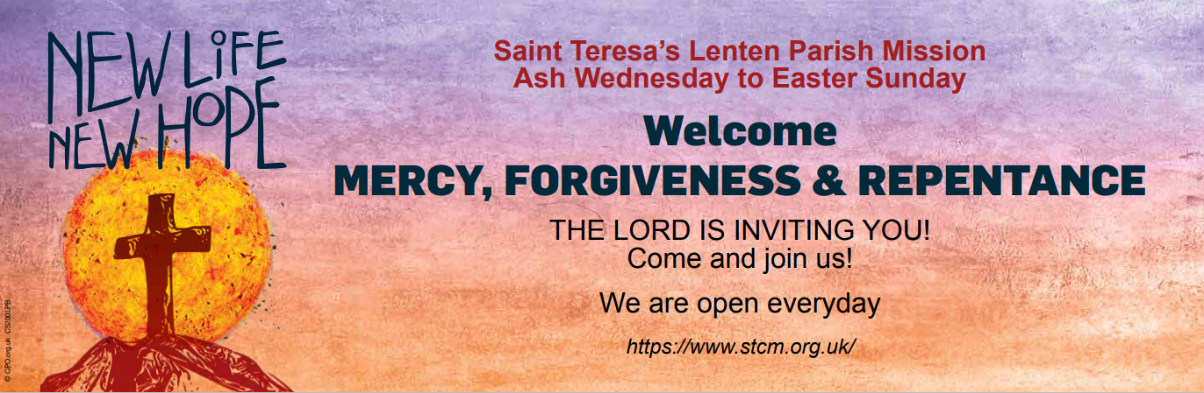

2 HOLY MASSES EVERYDAY
CONFESSION EVERYDAY
SACRAMENT OF THE SICK
MINI RETREATS
FAMILY SUPPORT
CATECHESIS
YOUTH MINISTRY
MOTHERS DAY
MUSIC
BLESSING OF CHILDREN
MASS OF ANTONEMENT
SCHOOL MINISTRY
MASS OF THE FAMILY TREE

Our Masses are also available online at
https://www.stcm.org.uk/
All Services are streamed on YouTube

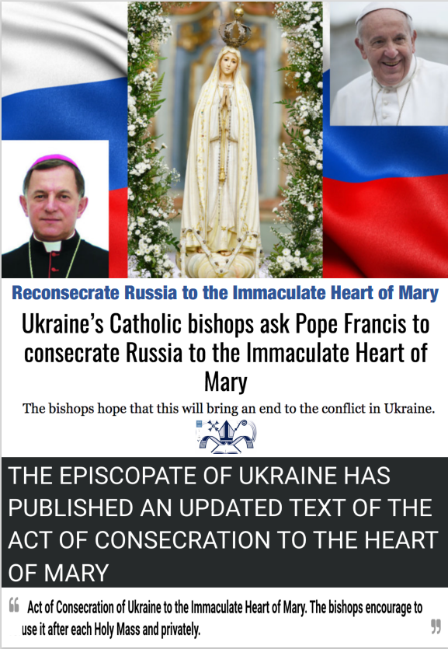

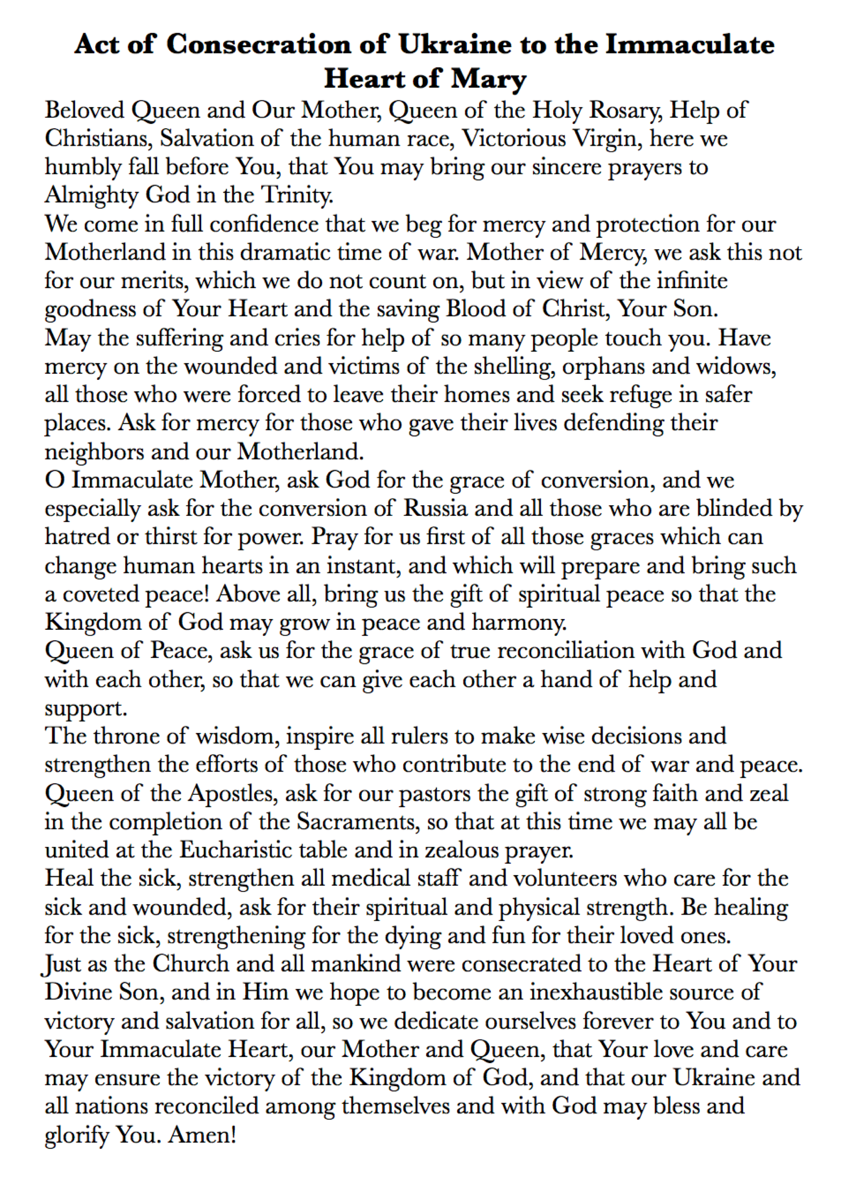

Lord Jesus,

You healed the sick, we bring to you in our prayer every day the sick and housebound, those coping with cancer and other serious health issues.

Please hear our prayer for:

Anne-Marie Mendonça, Moira Macklin, Maureen Smith, Maureen Flaherty,
John McDonagh, James Diver, Francesco Gargano, Theresa McGoldrick, Patricia Jayasena,
Jean Lue, Ruba Santipillai, Baby Alexander Lynch, Erika Geddes, Denise Waaldjk, Valerie Somerset, Leonard James Connolly, Thea Haddad, Margaret Lahy, Brian Wratten, Ann Van Essen and Jane Turner, Kevin Mooney, John Mooney, Angela Patcheye, Leonard Paice, Ken and Margaret Peacock, Michael and Madge Durkan, Jocyln De Silva, Mary Jeanette Connaire, Mary Reilly, Alan O’Leary, Bill and June O’Keefe, Gerry Gillan, Bella Harding, Eileen Stevens, Dave Herris, Gabriel Lyons, Sylvester Forya, Antonina Urbni, Tony London, Kevin McKeon, Vincent Moyle,
John Antao, Stella Carrasco, Gerald Pereira, Theresa Mathison, Jason Sigalas, Reme Mills,
Pope Francis and Pope Benedict, Pope Emeritus.

If you wish to be prayed for on our Parish Sick List, please let us have your name.
Every First Friday we offer and remember you in Holy Mass. We also keep you in our daily prayer, our times of Adoration, Novena’s and the Holy Rosary.

Dear Parishioners, please continue to remember the Sick Clergy of the diocese and send out your blessing in prayer to all the Nations of the World, as they do their best to combat the pandemic and natural disasters that many nations are battling with at this time. THANK YOU!

FOR THOSE CALLED TO ETERNAL LIFE
O gentle Heart of Jesus, ever present in the Blessed Sacrament, our parish family commends to you those who lived out their faith in our midst, those shared in our life here on earth.
And in these days to come those whose anniversaries occur as we enter the month of March

May they Rest in Peace and Rise in Glory.
RECENT DEATH
Now At Rest And Kept In Prayer

Avril Jean Costella RIP Francis Assisi Mendonça RIP
Shirley Johnson RIP Joseph Antony Quintus Rabindran RIP
Dermot Peter Long RIP Lourdes Mary Fatima Jayandradevi Rabindran RIP
Remo Dipre RIP Irene Ward RIP
Alan Frederick Burridge RIP Remo Corsini RIP
Sarah Marie Frost RIP Jonny Purvis RIP
Veronica Gorrod RIP Ann Donaldson RIP
Finbarr Francis Hurley RIP Baby Angelika Hobbs RIP
Lolito Laydia RIP Annie Francis RIP
Michael O’Kelly RIP Giovanni Mansini RIP
Newton Coutinho RIP Joseph Lunn RIP
Anna Darby RIP Norah Mary Williams RIP
Mary Creighan RIP Francisco José Carrasco RIP
Michael Joseph Nihill RIP Eva Sereny RIP
Gerald O'Toole RIP Steven Duggan RIP
Sarah Hedy Connolly RIP Lena McBride RIP
Sotelo Cabrera RIP Mary Whelan RIP
Noel Ryan, RIP Mary Connolly RIP
Michael Scott RIP Kevin Mattimoe RIP
Anna-Maria Fantocchi RIP Michael Bourke RIP
Giovanni Corsini RIP Dorothy Gertrude Cleary RIP
Gerry Kirrane RIP Frances Healion RIP
Gay Phillips RIP Douglas Banks RIP
Tony Byrnes RIP Robert Peter RIP
Jane Neyman RIP Dennis Leadley RIP
Christopher O’Byrne RIP Daniel Samuels RIP
Jose Goncalves RIP Michael McAndrew RIP
Sheila Borg RIP Shanti Annette Thesailankaimannan RIP
Theresa Mason RIP Mark Ryan RIP
Elaine Goldson-Rhule RIP

Recent Southwark Diocese Clergy Deaths
Deacon William Boyd RIP Fr. Richard Diala RIP
Deacon Jim Hayes RIP Fr. Michael Boland RIP
Fr. Paul Sanders RIP Fr. Robert Copsey SOLT RIP
Canon Richard Hearn RIP Deacon Vincent Bowgett RIP May They Meet The Risen Lord

Remind us Dear Lord, of the great company of your people who have been called before us, famed or forgotten, celebrated or overlooked, all who have run their race and kept the faith, walking the way of Christ to their journeys end.

Hear our prayer and the prayer of our Rosaries for those whose anniversaries occur at this time.

ANNARATHNAME SOOSAIPILLAI RIP
Annarathname, the mother of one of our parishioners, Vimalarose Colin and a frequent visitor to Saint Teresa’s died suddenly on Wednesday 23rd February at home. Annarathname, a mother of thirteen children, was 89 years old when she passed away. Our prayers and condolences go out to Vimalarose, her sisters who are nearby, her brothers in France and all the family.

May Annarathname Rest in Peace and Rise in Glory

PATRICIA PERRYMAN RIP
Our thoughts and prayers go out to the family of Patricia Perryman who sadly died at an early age of 67 years old. We remember especially her husband George and her son Simon. Although Patricia recently lived in Battersea she and George were married by Fr. Gill here at Saint Teresa’s in 1980. Patricia is one one of ten siblings and we remember them all.

May Patricia Rest in Peace and Rise in Glory
TERESA GOMES RIP
The beloved sister of Francis Mendes died on March 1st after some time of illness. Teresa, who was 74 years leaves behind a son, daughter and two grandchildren. Trained as a teacher, Teresa spent all her life until retirement teaching in a large Catholic Secondary School in Dhaka. Any Spare time was involved with the local Church, community and organisations.
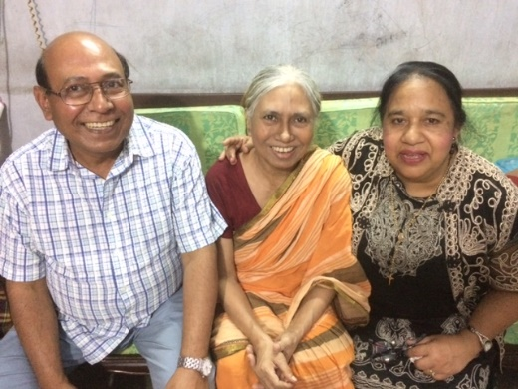
She was the National President(Bangladesh) of Worldwide Marriage Encounter, which is represented in over 90 countries including UK and Ireland. She visited and presented lectures in a lot of South Asian Countries on Marriage, family Life and pro marriage movement. She wrote and published numerous articles in Catholic papers and journals. She was very popular and well respected and will be sorely missed.

May Teresa Rest in Peace and Rise in Glory

ANNE DUNNE RIP
Anne Dunne RIP, who died at the age of 79, passed away on 1st March. We send our prayers and condolences to Gerald, her son and all the family along with friends and neighbours.

May Anne Rest in Peace and Rise in Glory

OUR PARISH LENTEN MISSION ASH WEDNESDAY TO EASTER SUNDAY

Our theme is: MERCY, FOREGIVENESS & REPENTANCE
Please let family and friends know of our 47 Day Spiritual Journey.

And please,
Bring your laughter, bring your tears,
Bring your joy and bring your sorrow,
Bring your hopes, bring your fears,
Bring today, bring tomorrow.

Bring your fullness, bring your thirst,
Bring your weakness, bring your health,
Bring your best and bring your worst,
Bring your love ones, bring yourself,
Bring your faith and bring your doubt,
Bring your sorrow for sins past,
Bring a heart that seeks His Mercy.

Bring a soul that cries out for absolution,
Bring your prayer for family and friends,
Bring your spiritual needs, bring your offering for Lent.

The Lord will be here every day to meet you in Prayer, Mercy and Forgiveness. His healing touch for you and your soul is assured.

Let this Season of Lent be rich in blessings for you and your family.

We would like to invite you to a parish WALK AGAINST HUNGER this lent. Family Fast Day is on the 11th March and on Sunday 13th March after the 11am Mass we would like you to join us in helping stamp out hunger. We are challenging you to walk around the outside of the field adjacent to the church to raise money to help communities thrive in even the most difficult environments. We also ask you to pray for our brothers and sisters who are living in poverty. Thank you for your amazing support.
DEC – UKRAINE HUMANITARIAN APPEAL
https://www.dec.org.uk/?gclid=Cj0KCQiA64GRBhCZARIsAHOLriLrac5em-topByZ8D5L4luy7Ar6ewj7qJUEO4ahIr5d_XnRl3W3Sr4aAux2EALw_wcB
CAFOD (same one DEC fundraising)
https://cafod.org.uk/News/Emergencies-news/Ukraine-crisis
DEPAUL UKRAINE EMERGENCY APPEAL via The Tablet
https://int.depaulcharity.org/

RE: Fundraiser for Ukrainian refugees
Saturday 12th March, 7:30pm
Colliers Wood Community Centre, 66-72 High Street Colliers Wood, London SW19 2BY

We have all watched in horror at the Russian invasion of Ukraine. There is no doubt that this is a dark hour in history with consequences that will be tragic and felt around the world.

The Ukrainian people have been cast into war through no fault of their own. In Mitcham and Morden, we are united in our concern for their plight. I know that watching the war unfold has been both worrying and upsetting and that many people have felt a sense of helplessness. Over half a million Ukrainians have fled already, seeking safety in neighbouring countries including in Poland. But we can help: there has been a call for humanitarian aid and I know that our community will respond!

And so on Saturday 12th March from 7:30pm a fundraising evening will be held at Colliers Wood Community Centre to raise vital funds for the Polish Family Association who are providing food and essential items to Ukrainian families who have fled into Poland.

Tickets are a recommended donation of £20, with 100% of the funds raised going directly to the Polish Family Association. The evening will include FREE delicious food from the wonderful Colliers Wood Tandoori, FREE alcohol and soft drinks, and FREE live music from renowned jazz singer Gill Manly.

Tickets are available at www.justgiving.com/fundraising/raising-funds-for-ukrainian-refugees or please call 0208 542 4835 for more information. We are asking for anyone who would like to attend to please donate in advance of the evening and to leave a comment with their donation to confirm whether they are attending the fundraising evening or just donating so that we can cater accordingly!

This is a ticketless event so we are asking that attendees bring their email confirmation on the night to show their donation.

I hope that you can come along and that you will be able to share details of the fundraiser with friends, family and neighbours. Together, Mitcham and Morden will stand with our friends in Ukraine.

My best wishes,

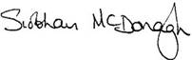
Siobhain McDonagh MP for Mitcham and Morden
P.S. Please do invite friends, family or members of your community to our fundraiser. Everyone is welcome at 7.30pm on Saturday 12th March. For tickets to the fundraiser, please visit www.justgiving.com/fundraising/raising-funds-for-ukrainian-refugees. An attached poster is available to print off and share with your community.

CLERGY SUPPORT FUND SECOND COLLECTION
The Clergy Support Fund of the Archdiocese of Southwark provides care for priests in their old age and retirement, and in their time of ill health. A gift to this worthy fund will ensure a dignified retirement for our priests, after they have dedicated a lifetime of service to Christ, His Church and His People.

In 2021, the Clergy Support Fund provided care to 71 retired priests, at a cost of £1.25 million. With the number of priests over the age of 65 steadily increasing, so too will the financial obligation to the Archdiocese. Please be generous today with a gift to the Clergy Support Fund and continue to keep our priests in your prayers.

Thank you! · Donate Online: https://rcaos.org.uk/donate/csf

· QR Code (see right)
· Telephone Mon-Fri 9am-5pm: 020 7960 2504
· Cash / Cheque – please use the Clergy Support Fund envelopes at the back of church.

SYNOD
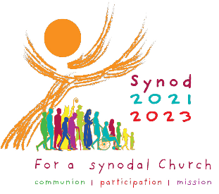
Thank you to everyone who took part in the first phase of the Synod Survey over the past few months. We had over fifty responses from parishioners both online and returned survey forms.

These responses formed the basis of the report, which was sent, along with all other parishes, to Southwark Diocese and will be reviewed. Southwark’s response, presented to the Bishop’s Conference of England and Wales will then be collated along with all other Diocese across the country, before submission to Rome.

There were many heartfelt, honest and spiritual responses feeding into the themes of Communion, Participation and Mission. The results also highlighted valued aspects, as well as suggested enhancements specific to Saint Teresa’s. Many of these ‘missing’ or ‘lacking’ areas of parish life were due to COVID-19 and the restrictions it brought. Listed below are some of the areas which were highlighted, and which in due course can be addressed within Saint Teresa’s.

DETAIL | RESPONSE
Social Interactions/Events | COVID closure - Awaiting work on parish centre
Children's Mass/Liturgy/Participation | COVID restrictions – Liturgy coming back soon,  Children’s Masses will be held during the Mission.
More volunteers/Requests for | Anyone who wishes to volunteer within the parish, please leave your contact details with a PPC member at the contact corner when it re-opens. It is hoped to hold a Volunteers Day in the future.
Contact Info/Comms | A notice will be displayed at the Contact Corner
Newsletter | COVID restrictions – printed newsletter will be returning
More/Bring back choir | COVID restrictions – music groups are gradually returning
Missions / Retreats | Lenten Mission NEW LIFE, NEW HOPE! Begins Ash Wednesday 2nd March.
Adoration | COVID restrictions – Adoration will begin to return during the Parish Mission.
Indoor confession | COVID restrictions - Confessionals will return when safe
Repository | COVID restrictions - will be open soon. Restricted access is available via the parish office.
Social Distancing | Canon Michael continues to encourage masks & distancing should remain as much as possible.
Prayer Groups | COVID Restrictions - coming back slowly
Toilets | COVID restrictions - The toilet blocks are now back in operation
Visits & Home Blessings | COVID restrictions - coming back eventually. There are still strict regulations around visiting homes, as well as safeguarding aspects.

APPRENTICESHIP & HIGHER EDUCATION - HELP AND ADVICE
St Boniface Youth and 20’s & 30’s Group is organising two sessions: Help and advice on
Apprenticeships: on Saturday 5th March 3-4pm and
Higher Education: on Saturday 12 March 3-4.30pm at St Boniface Parish Hall.
All Year 11 & 12 or any year group and parents are most welcome. An opportunity to speak to professionals to get some help and advice for their career and future.
St. Boniface Church,185 Mitcham Road, Tooting, SW17 9PG

Saint Teresa's
LIFE is remembered
LOVE is deepened, HOPE is rekindled,
FAITH is awakened,
FAITH is renewed,
FAITH is strengthened,
Where BLESSINGS from Heaven await you.
Where the LORD OF DIVINE MERCY forgives you.
Where the Mother of God prays for you.
Where Saint Teresa intercedes for you.
Where Saint Joseph seeks to help you.
Where the Parish Family pray for you.
WELCOME - WELCOME - WELCOME

NEW MARRIAGE LAW
Please be aware of the following change in the law which takes effect from 1ST July 2021!

Immigration laws for EEA nationals will change from the 1 July to reflect the changes brought about following EU Exit. These changes will impact EEA citizens who wish to marry in England and Wales as the definition of a relevant national has changed. A relevant national, from the 1 July 2021, will be classed as:
• A British Citizen
• An Irish Citizen
• An EEA National who has been granted Settled or Pre-settled status under the EU Settlement
Scheme (EUSS) or those with a pending application submitted before the 30 June 2021.
Currently couples who are subject to immigration control must make an appointment at one of 75 Designated Register Offices within England and Wales to give notice to marry. From the 1 July 2021, all register offices will be designated for the purposes of taking a marriage for these couples.

An EEA national who does not hold a status under the EUSS will be treated as all other foreign
nationals and will have to give notice of their intention to marry (together with their partner) at a
register office in the registration district where either resides and be issued with a Marriage Schedule.

PARISH FINANCE
Sunday Collections and Donations

During the current situation, we would like to say a huge THANK YOU to the many of you who have kindly signed up to standing orders. This is so much appreciated and valued. If you wish to contribute by cheque in lieu of plate collections, this can be sent to the presbytery: St. Teresa’s Church, 250, Bishopsford Road, Morden, Surrey, SM4 6BJ. They may be made payable to St. Teresa’s Catholic Church.

Many thanks to those of you who have so kindly offered to set up standing orders in lieu of our Sunday plate collections. This is a most convenient method of planned giving (for all concerned); already used by so many at Morden – and is vitally important at this time. Regular standing orders can be for any amount, no matter how small – just give what you can afford. Please send a written request via the parish office with contact details.

We will be happy to receive any offerings directly by on-line banking or by standing order, which can be arranged through your bank, or by using the DONATE link here or on the parish website.

Do You Gift Aid?

The value of your donation can be increased by 25% at no extra cost to yourself, simply by gift aiding it if you are a taxpayer. The parish learns nothing about your private financial affairs. The average weekly collection between plate and standing orders, was approximately £2,400 a week (pre-COVID). If only half of that was GIFT AIDED, it would mean an extra £300 a week, or £15,600 a year to Parish funds. We are genuinely grateful to those who are Gift-Aiding. If you haven’t been doing so, please print off a Gift Aid form from the parish website. At the present time the parish income is down about £5,000 each month. Hopefully, when parish life returns to normal, we will soon see these financial worries and concerns disappear.

Thank you to everybody who continues to support the parish through the collection, standing orders, gift aid and dropping in contributions. Online donations have seen an increase recently - A big THANK YOU FOR THOSE DONATIONS coming in via our parish website 'JUST GIVING' - Press the button marked DONATE. If you scroll down further, we also say 'Thanks' for your support and other ways you can support our parish. Again, THANK YOU.

GIFT AID NOTICE – HAVE YOU COLLECTED YOUR GIFT AID BOX?
PLEASE COLLECT YOUR GIFT AID ENVELOPES FROM THE
CONTACT CORNER

For those already signed up, Gift Aid Envelopes are available. Please collect your Gift Aid or Standing Order envelopes before or after Mass from the Contact Corner. If no one is at the Contact Corner, please ask one of the Stewards for Linda or Lorraine.
If you pay tax and would like to join, please have a word with one of the team, it is simple and at no extra cost to you the Church can claim back 25%. See below for more details Do You Gift Aid?

CARD READERS
To make things easier we have now introduced a number of card readers, which you will find throughout the church. The CollecTin reader is near the Icon of Padre Pio, instructions are listed next to the machine. You can use this for all offertories and donations.

The Sum-Up card reader will be situated in the narthex near the statue of St Teresa and can be used only for candles. Coming soon in the Repository will be another card reader so that you can pay for all your purchases using a credit debit card.

COLLECTIN
CollecTin is a card reader on which you can give your offertory and any other donation. All special collections will be listed on this machine and if you Gift Aid you need only register once, and it will remember you for all your donations - if you use the same card (each card would need to be registered).
CANDLES

SUMUP CARD READER
- IF THE SCREEN IS BLANK press the power button
- ENTER THE AMOUNT YOU WISH TO DONATE
e.g. 5 0 0 is £5.00, press the green tick button
- TAP CARD for contactless or INSERT CARD using your pin
- SELECT RECEIPT use arrows to select option required

QR SCAN POINTS
There is now the opportunity to donate using a QR Scanner on your phone (if you have one installed).There are a number of Scan points in the church, one by the Statue of the Sacred Heart, one by the Exit side door and one on the noticeboard in the porch.
THANK YOU FOR YOUR FINANCIAL SUPPORT – IT’S VALUED AND APPRECIATED!

Please Be Aware.

At this time, there is an increasing risk of cybercrime and online fraud. If you ever receive an email stating a change in bank account details purporting to be from the Archdiocese or from any of the diocesan parishes, please contact the diocese immediately by telephone on 020 8682 7880 in order to verify that the email is genuine and not a scam.
* * * * * * * * * * * * * * * * * * * * * * * * *

Guidance for Lent and Easter 2022
CATHOLIC BISHOPS’ CONFERENCE OF ENGLAND AND WALES

Introduction
As the Government has now lifted most of the covid-19 restrictions and exhorted all people to adopt the recommendations of the “Covid Response: Living with covid-19” document, the principal means of protecting people who attend Catholic Churches in England and Wales is through participation in the Government vaccination programme. Those who are fully vaccinated (i.e. two routine vaccinations plus booster) will have significant personal resilience against major illness from the covid-19 virus and its variants. The Catholic Church has promoted the participation of all in the vaccination programme as part of its mitigation of virus transmission in church and ancillary buildings.
Alongside the positive effects of covid vaccination, it should be stressed that any people displaying symptoms of Covid-19 should stay at home and not participate in acts of worship in church. This is good practice for any transmissible illness. Medical advice should be sought as appropriate for those who are ill.
The following points are suggested as methods of good practice against the transmission of the virus in our churches:
- Hand sanitiser should be available for all to use at places of entry and exit to our churches.
- The necessity for social distancing is removed so churches should operate up to their normal capacity figures.
- Those who wish to wear a face covering may do so during the celebration of Mass.
- The use of hymn books and other worship aids are permitted as part of the liturgy. Servers and their various ministries (acolyte, book-bearer, incense) are to be encouraged to return.
- The vessels containing the altar breads for consecration at Mass should remain covered until the moment of distribution of Holy Communion to the faithful.
- Holy Communion is to be distributed to the faithful under one kind only (i.e. the Sacred Host). At concelebrations involving a number of priests, communion for them should be by intinction of the Sacred Host in the Precious Blood.
- Those who distribute Holy Communion should wear a face covering and sanitise their hands before doing so.
- Singing can occur and there is a general encouragement to wear face coverings while singing. However, it is recognised that not everyone will feel able to do this.
- Contact tracing ended on 24th February and so there is no need for track and trace QR codes or other means (e.g. Mass booking systems) in our churches from now on.

Specific notes for Lent and Easter
On Ash Wednesday, the imposition of ashes should take place at the normal point in the liturgy.
These can be administered in two ways:
- The traditional way in these countries of daubing a cross on the forehead of the person.
- The “continental” manner of sprinkling the ashes on the crown of the penitent.
In either case, the person distributing the ashes should sanitise their hands before and wash them afterwards and wear a face covering.

On Holy Thursday, the Washing of the Feet as part of the rite of the Mandatum is restored. The celebrant should wear a face covering whilst performing this rite.

On Good Friday, the Veneration of the Cross is also restored. Those who approach the Cross, after making the customary reverence before it, can either touch the Cross in a devotional way or kiss the Cross provided that an alcoholic wipe is used to clean the place that is venerated after each kiss by the faithful.

The Easter Vigil is restored in its full Rite. The faithful gathering for the ceremonies can have candles and the baptismal liturgy can take place along with any associated confirmations. For the anointings as part of this, the thumb or a cotton bud can be used, with the celebrant taking care to cleanse his hands appropriately. The sprinkling of the faithful during the vidi aquam is permitted.

Conclusion
Whilst the circulation of the virus continues in society, the clear direction of the UK Government is that after two years of restrictions and following the successful roll-out of the vaccination programme, the usual patterns of life should return. This is true for the life of the Church in England in Wales in all of its activities. Whilst recognising this principle, there should be vigilance at the local level in terms of viral infection and transmission and local adaptations should be put in place.

Rev. Canon Christopher Thomas
28th February 2022
FINAL

PERFECT CONTRITION AND SPIRITUAL COMMUNION
What to do if you cannot go to Confession or Holy Communion due to the COVID-19 coronavirus: If you have to self-isolate or are quarantined, you will be unable to receive the sacraments as normal. In these circumstances, there are devotions through which you can receive absolution for your sins (under certain conditions), and the consolation of Eucharistic grace.
The following devotions are officially encouraged by the Church and have been practised by saints.
How to make an Act of Perfect Contrition

Through an act of Perfect Contrition, you receive pardon for your sins outside of
confession, even mortal sins, on condition that you are determined to amend your
life and make a firm resolution to go to sacramental confession as soon as this
becomes possible for you.

Perfect Contrition is a grace from God, so sincerely ask for this gift throughout the day prior to making your act of contrition: ‘My God, grant me perfect contrition for my sins.'

- In reality or imagination kneel at the foot of the crucifix and say to yourself: “ Jesus, my God and my Saviour, in the midst of your agony, you remembered me, you suffered for me, you wished to wipe away my sins”

- Contrition is ‘perfect’ if you repent your sins because you love God and are sorry for having offended Him and causing the sufferings of Christ on the cross. Before the Crucified Christ remember your sins, repent of them because they have bought Our Lord His sufferings on the cross. Promise him that with His help, you will not sin again.

- Recite, slowly and sincerely, an act of contrition focussed on the goodness of God and your love of Jesus: “O my God, because You are so good, I am very sorry that I have sinned against You and by the help of Your grace I will not sin again. Amen.”
- Make a firm resolution to go to a sacramental confession as soon as practically possible.

How to make a Spiritual Communion

The key to Spiritual Communion is to grow in your heart a constant desire for the Blessed Sacrament.

- If you are aware of serious or mortal sin, make an Act of Perfect Contrition
- Imagine the sacred words and actions of the Mass or watch online or on TV.
- Make all those acts of faith, humility, sorrow, adoration, love and desire that you usually express before Holy Communion.
- Desire, with earnest longing, to receive Our Lord present – Body, Blood, Soul and Divinity – in the Blessed Sacrament.Say the prayer of St. Alphonsus de’ Ligouri – The Prayer of Spiritual Communio
After moments of silent adoration make all those acts of faith, humility, love, thanksgiving and offering that you usually express through prayers after Holy Communion.
